Please note this report should be submitted with the pre-populated document received from the Child Protection Unit

Section 1 – Report Author

Report compiled by: | GP to insert
Job Title: | GP to insert
Date Report Completed: | GP to insert
Safeguarding lead at practice:  (if different to above) | GP to insert
Contact details for queries: | GP to insert

Section 2 – Changes since last Case Conference in Child(ren) or Parents health or social situation where known (review period usually 3 months), please provide analysis of what this means for the child
NOTE: If there has been no contact with the family during the review period this could still be relevant so please complete and return form stating this.

Section 3 – Analysis of health needs

Having analysed the medical information for this report, I have:
 | Yes | No | Reason for decision:
Ongoing medical concerns |  |  | GP to insert free text here
Concern regarding the health seeking behaviour of the family |  |  | GP to insert free text here
Concern regarding parenting capability |  |  | GP to insert free text here
Concern that the child’s current needs may require support within a multiagency protection plan |  |  | GP to insert free text here

Section 6 – Analysis for the Multiagency Conference
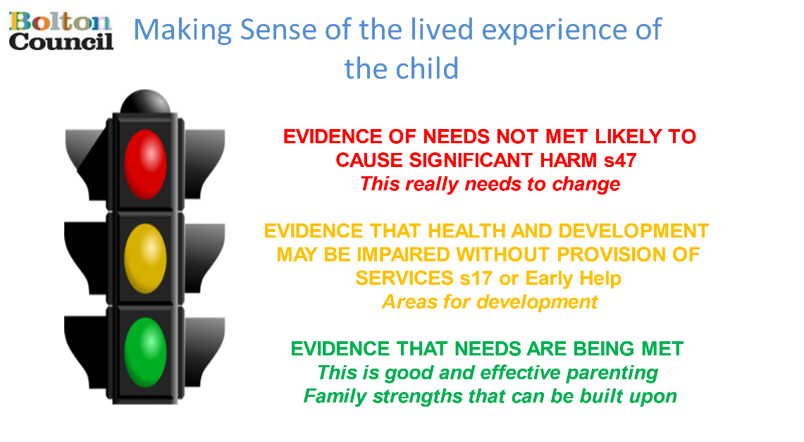

GREEN: Evidence that needs are being met:
AMBER: Evidence that health and development may be impaired without the provision of services:
RED: Evidence of needs not met and likely to cause significant harm:
Impact of risk upon the child/ren/young person. What might happen if nothing changes now or in the future?

